# National University of Technology



Computer Science Department Semester Spring– 2024 **Course: Oop**

|  |  |
| --- | --- |
| **Submitted to:** | **Submitted by:** |
| Mam Umm e Safiya | Mohtashim Anees |
| **Department:**  Computer Science | **F23605027** |

# Assignment 3:

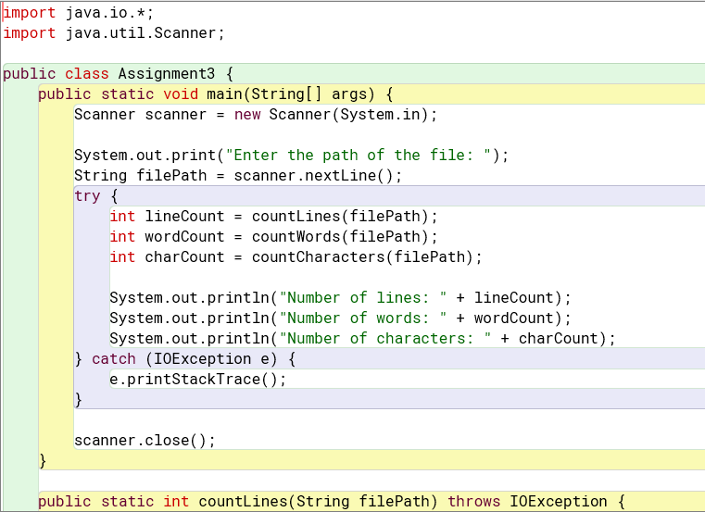

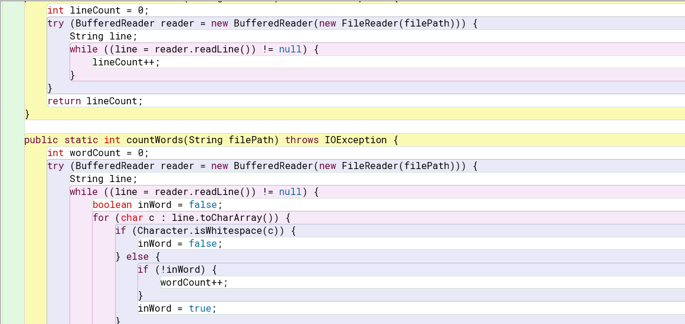

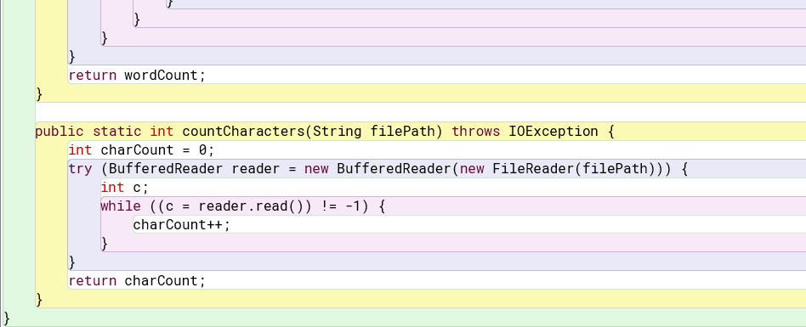

**Output:**

